IDIA Lab - Cave's Audio set up

Speakers Layout
Speaker: The number of the speaker and how it’s labeled.
Audio Ch.: The audio card’s channel in which speaker is connected to so it works with surround sound config.

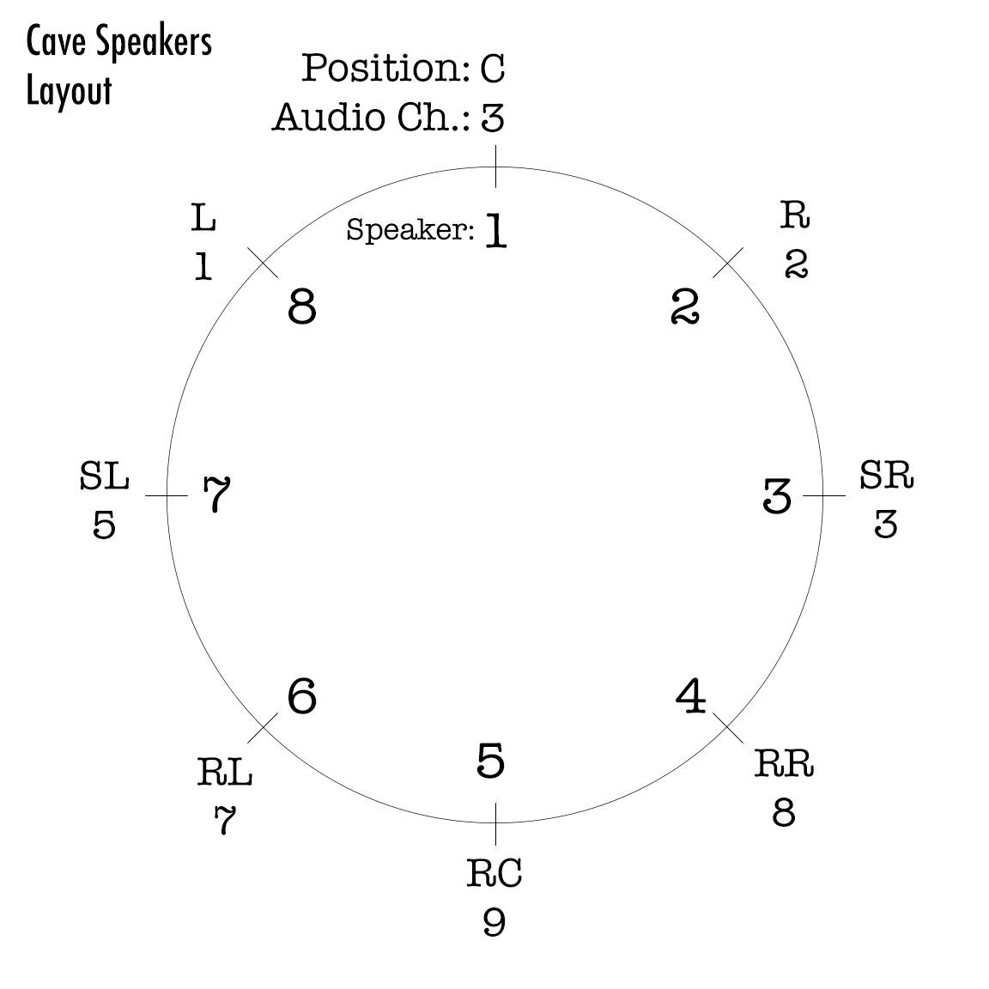

Denon Surround Amplifier

Cable Patching
From the PCs sound card to the Denon amplifier

C/Sub: White >> C | Red >> SW
Rear: White >> SBR | Red >> SR
Line Out: White >> L | Red >> R

P.S. It doesn't make sense! I think it’s a mismatch between the audio card and the driver, so I can’t get thi setup how it is supposed to be, but this way, if you are lucky, it will work.

Driver set-up
Control Panel >> Hardware and Sound Control >> Sound >> Select “Speakers” >> Configure Speakers >> 7.1 surround >> Select all

Scarlett 18i20

Cable Patching
The Scarlett should be used for more flexible configurations, so the speaker layout is up to you. However, that same layout can be used as a standard if you are receiving pieces with different speaker configurations. If using ambisonics, for example, you can use the center speaker on channel 1 and then go clockwise one by one on channel 2, 3, 4…

Driver set-up
On Max, or any other software, chose the Focusrite USB 2.0 Audio driver. If this doesn’t wok chose Focusrite USB ASIO.

